LAPORAN

WORKSHOP SISTEM INFORMASI
WEB SERVER (TIF330805)

SEMESTER 3



ACARA 10

NAMA:
MUHAMMAD AFIF RAMDHANI

NIM:
E41250223

PROGRAM STUDI DILUAR KAMPUS UTAMA (PSDKU)
TEKNIK INFORMATIKA KAB. NGANJUK
JURUSAN TEKNOLOGI INFORMASI
POLITEKNIK NEGERI JEMBER
TAHUN 2026

BAB 1 PENDAHULUAN

1.1 Judul Tugas

1.2 Tujuan Tugas

1.3 Dasar Teori
.
.

BAB 2 PEMBAHASAN

2.1 Alat dan Bahan
- Laptop/PC
- Web Browser
- Visual Studio Code
- XAMPP/Laragon
- PHP
- HTML, CSS, Bootstrap
- Modul Praktikum

2.2 Langkah-Langkah dan Hasil
- Buat app/Controllers/BaseController.php
Masukkan kode program
<?php

namespace App\Controllers;

abstract class BaseController
{
// Memuat tampilan dan menyediakan data sebagai variabel lokal.
protected function view(string $view, array $data = []): void
{
extract($data, EXTR_SKIP);

require __DIR__ . '/../Views/' . $view . '.php';
}

// Mengarahkan pengguna ke URL tujuan dan menghentikan proses.
protected function redirect(string $url): void
{
header('Location: ' . $url);
exit;
}
}

- Buat app/Core/BaseModel.php
Masukkan kode program
<?php

namespace App\Core;

use PDO;

require_once __DIR__ . '/Database.php';

abstract class BaseModel
{
protected PDO $pdo;

// Gunakan koneksi yang disuntikkan atau koneksi singleton sebagai bawaan.
public function __construct(?PDO $pdo = null)
{
$this->pdo = $pdo ?? Database::getInstance();
}
}

- Ganti isi app/Repositories/MahasiswaRepository.php
Masukkan dengan kode program terbaru
<?php

namespace App\Repositories;

require_once __DIR__ . '/../Core/BaseModel.php';
require_once __DIR__ . '/../Models/Mahasiswa.php';

use App\Core\BaseModel;
use App\Models\Mahasiswa;
use PDO;

class MahasiswaRepository extends BaseModel
{
private const SELECT_BASE = "SELECT mahasiswa.*, prodi.nama_prodi
FROM mahasiswa
LEFT JOIN prodi ON mahasiswa.prodi_id = prodi.id";

// Koneksi PDO menggunakan konstruktor yang diwarisi dari BaseModel.
public function all(): array
{
$stmt = $this->pdo->prepare(self::SELECT_BASE . " ORDER BY mahasiswa.nama ASC");
$stmt->execute();

return $this->hydrateAll($stmt->fetchAll(PDO::FETCH_ASSOC));
}

public function search(string $keyword): array
{
$sql = self::SELECT_BASE . "
WHERE mahasiswa.nama LIKE :name_keyword
OR mahasiswa.nim LIKE :nim_keyword
ORDER BY mahasiswa.nama ASC";

$stmt = $this->pdo->prepare($sql);
$pattern = '%' . $keyword . '%';
$stmt->execute([
'name_keyword' => $pattern,
'nim_keyword' => $pattern,
]);

return $this->hydrateAll($stmt->fetchAll(PDO::FETCH_ASSOC));
}

public function find(int $id): ?Mahasiswa
{
$stmt = $this->pdo->prepare(self::SELECT_BASE . " WHERE mahasiswa.id = :id");
$stmt->execute(['id' => $id]);

$row = $stmt->fetch(PDO::FETCH_ASSOC);

return $row ? Mahasiswa::fromArray($row) : null;
}

public function create(Mahasiswa $mahasiswa): int
{
$stmt = $this->pdo->prepare(
"INSERT INTO mahasiswa (nim, nama, prodi_id, email)
VALUES (:nim, :nama, :prodi_id, :email)"
);

$stmt->execute([
'nim' => $mahasiswa->getNim(),
'nama' => $mahasiswa->getNama(),
'prodi_id' => $mahasiswa->getProdiId(),
'email' => $mahasiswa->getEmail(),
]);

return (int) $this->pdo->lastInsertId();
}

public function update(Mahasiswa $mahasiswa): bool
{
$stmt = $this->pdo->prepare(
"UPDATE mahasiswa
SET nim = :nim, nama = :nama, prodi_id = :prodi_id, email = :email
WHERE id = :id"
);

return $stmt->execute([
'id' => $mahasiswa->getId(),
'nim' => $mahasiswa->getNim(),
'nama' => $mahasiswa->getNama(),
'prodi_id' => $mahasiswa->getProdiId(),
'email' => $mahasiswa->getEmail(),
]);
}

public function delete(int $id): bool
{
$stmt = $this->pdo->prepare("DELETE FROM mahasiswa WHERE id = :id");

return $stmt->execute(['id' => $id]);
}

private function hydrateAll(array $rows): array
{
return array_map(
static fn (array $row): Mahasiswa => Mahasiswa::fromArray($row),
$rows
);
}
}

- Ganti isi app/Models/Prodi.php
Masukkan denga kode program terbaru
<?php

namespace App\Models;

require_once __DIR__ . '/../Core/BaseModel.php';

use App\Core\BaseModel;
use PDO;

class Prodi extends BaseModel
{
public function all(): array
{
$stmt = $this->pdo->prepare("SELECT * FROM prodi ORDER BY nama_prodi ASC");
$stmt->execute();

return $stmt->fetchAll(PDO::FETCH_ASSOC);
}

public function find(int $id): array|false
{
$stmt = $this->pdo->prepare("SELECT * FROM prodi WHERE id = :id");
$stmt->execute(['id' => $id]);

return $stmt->fetch(PDO::FETCH_ASSOC);
}

public function create(array $data): bool
{
$stmt = $this->pdo->prepare(
"INSERT INTO prodi (kode_prodi, nama_prodi) VALUES (:kode_prodi, :nama_prodi)"
);

return $stmt->execute([
'kode_prodi' => $data['kode_prodi'],
'nama_prodi' => $data['nama_prodi'],
]);
}

public function update(int $id, array $data): bool
{
$stmt = $this->pdo->prepare(
"UPDATE prodi SET kode_prodi = :kode_prodi, nama_prodi = :nama_prodi WHERE id = :id"
);

return $stmt->execute([
'id' => $id,
'kode_prodi' => $data['kode_prodi'],
'nama_prodi' => $data['nama_prodi'],
]);
}

public function delete(int $id): bool
{
$stmt = $this->pdo->prepare("DELETE FROM prodi WHERE id = :id");

return $stmt->execute(['id' => $id]);
}
}

- Ganti isi app/Controllers/ProdiController.php
Masukan kode program terbaru
<?php

namespace App\Controllers;

require_once __DIR__ . '/BaseController.php';
require_once __DIR__ . '/../Models/Prodi.php';

use App\Models\Prodi;

class ProdiController extends BaseController
{
public function index(): void
{
$model = new Prodi();

$this->view('Prodi/index', ['prodi' => $model->all()]);
}

public function create(): void
{
$this->view('Prodi/create');
}

public function store(): void
{
$model = new Prodi();
$model->create([
'kode_prodi' => $_POST['kode_prodi'],
'nama_prodi' => $_POST['nama_prodi'],
]);

$this->redirect('/si-akademik/public/prodi');
}

public function edit($id): void
{
$model = new Prodi();
$prodi = $model->find((int) $id);

if (!$prodi) {
http_response_code(404);
echo 'Data prodi tidak ditemukan';
return;
}

$this->view('Prodi/edit', ['prodi' => $prodi]);
}

public function update($id): void
{
$model = new Prodi();
$model->update((int) $id, [
'kode_prodi' => $_POST['kode_prodi'],
'nama_prodi' => $_POST['nama_prodi'],
]);

$this->redirect('/si-akademik/public/prodi');
}

public function destroy($id): void
{
$model = new Prodi();
$model->delete((int) $id);

$this->redirect('/si-akademik/public/prodi');
}
}

- Ganti isi app/Models/MataKuliah.php
<?php

namespace App\Models;

require_once __DIR__ . '/../Core/BaseModel.php';

use App\Core\BaseModel;
use PDO;

class MataKuliah extends BaseModel
{
public function all(): array
{
$stmt = $this->pdo->prepare("SELECT * FROM mata_kuliah ORDER BY nama_mk ASC");
$stmt->execute();

return $stmt->fetchAll(PDO::FETCH_ASSOC);
}

public function find(int $id): array|false
{
$stmt = $this->pdo->prepare("SELECT * FROM mata_kuliah WHERE id = :id");
$stmt->execute(['id' => $id]);

return $stmt->fetch(PDO::FETCH_ASSOC);
}

public function create(array $data): bool
{
$stmt = $this->pdo->prepare(
"INSERT INTO mata_kuliah (kode_mk, nama_mk, sks) VALUES (:kode_mk, :nama_mk, :sks)"
);

return $stmt->execute([
'kode_mk' => $data['kode_mk'],
'nama_mk' => $data['nama_mk'],
'sks' => $data['sks'],
]);
}

public function update(int $id, array $data): bool
{
$stmt = $this->pdo->prepare(
"UPDATE mata_kuliah SET kode_mk = :kode_mk, nama_mk = :nama_mk, sks = :sks WHERE id = :id"
);

return $stmt->execute([
'id' => $id,
'kode_mk' => $data['kode_mk'],
'nama_mk' => $data['nama_mk'],
'sks' => $data['sks'],
]);
}

public function delete(int $id): bool
{
$stmt = $this->pdo->prepare("DELETE FROM mata_kuliah WHERE id = :id");

return $stmt->execute(['id' => $id]);
}
}

- Ganti isi app/Controllers/MataKuliahController.php
Masukkan kode program terbaru
<?php

namespace App\Controllers;

require_once __DIR__ . '/BaseController.php';
require_once __DIR__ . '/../Models/MataKuliah.php';

use App\Models\MataKuliah;

class MataKuliahController extends BaseController
{
public function index(): void
{
$model = new MataKuliah();

$this->view('MataKuliah/index', ['mataKuliah' => $model->all()]);
}

public function create(): void
{
$this->view('MataKuliah/create');
}

public function store(): void
{
$model = new MataKuliah();
$model->create([
'kode_mk' => $_POST['kode_mk'],
'nama_mk' => $_POST['nama_mk'],
'sks' => $_POST['sks'],
]);

$this->redirect('/si-akademik/public/mata-kuliah');
}

public function edit($id): void
{
$model = new MataKuliah();
$mataKuliah = $model->find((int) $id);

if (!$mataKuliah) {
http_response_code(404);
echo 'Data mata kuliah tidak ditemukan';
return;
}

$this->view('MataKuliah/edit', ['mataKuliah' => $mataKuliah]);
}

public function update($id): void
{
$model = new MataKuliah();
$model->update((int) $id, [
'kode_mk' => $_POST['kode_mk'],
'nama_mk' => $_POST['nama_mk'],
'sks' => $_POST['sks'],
]);

$this->redirect('/si-akademik/public/mata-kuliah');
}

public function destroy($id): void
{
$model = new MataKuliah();
$model->delete((int) $id);

$this->redirect('/si-akademik/public/mata-kuliah');
}
}

- Pengujian
Buka Xampp dan nyalakan Apache dan MySQL. Buka http://localhost/si-akademik/public/, lakukkan login, lalu uji:

Tampilkan data Mahasiswa
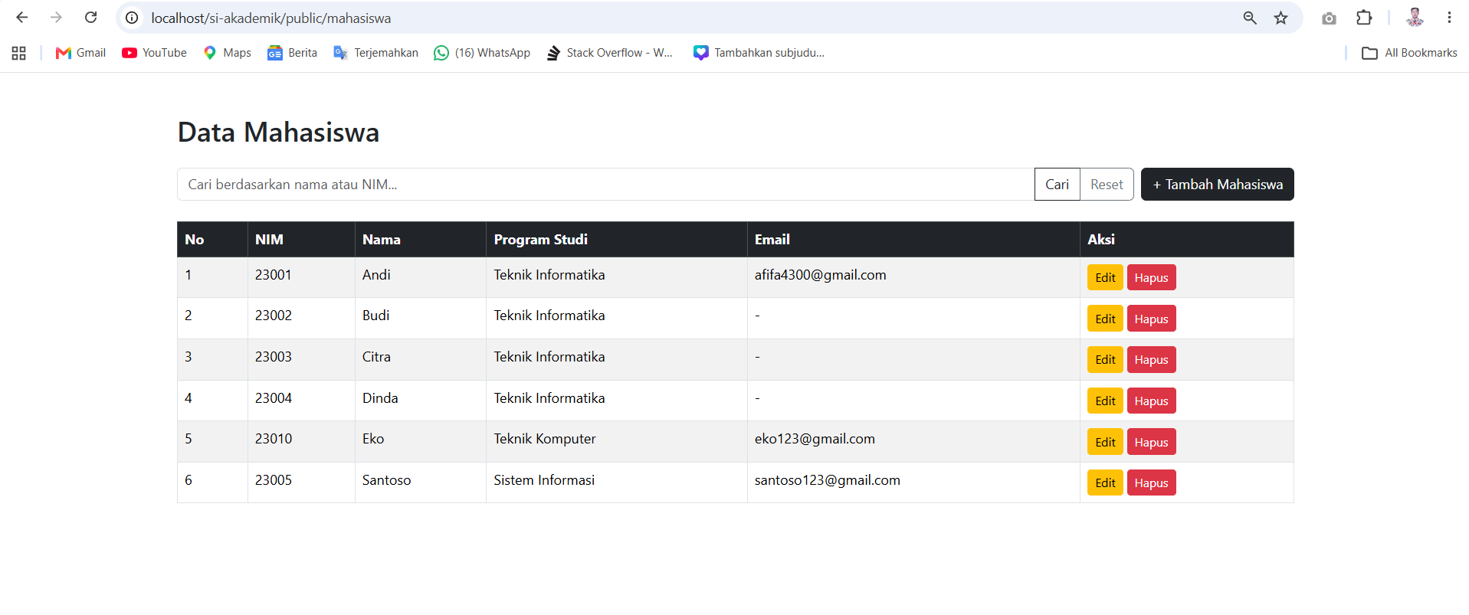

Cari nama, setelah itu reset
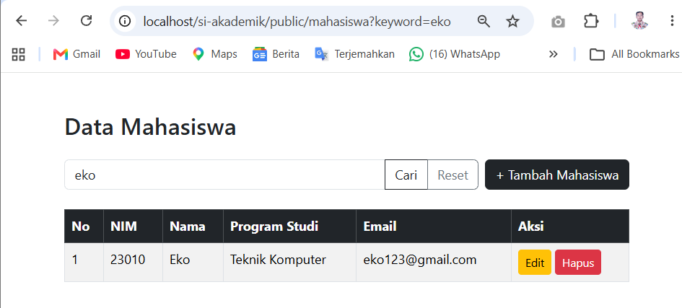

Reset
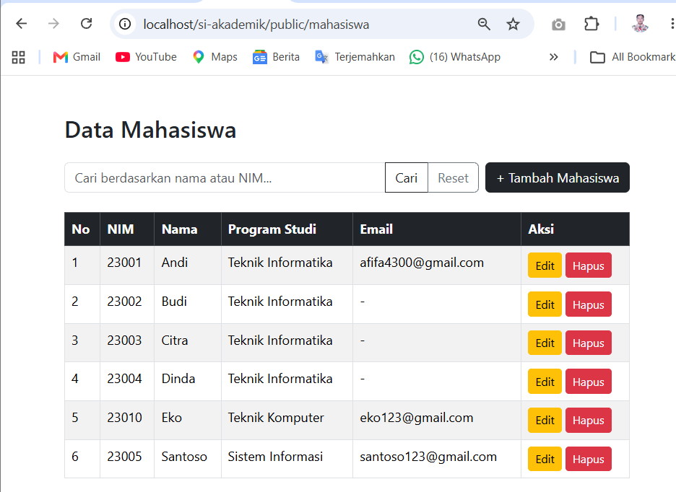

Tambah data mahasiswa
Klik tambah mahasiswa, lalu masukkan data mahasiswa
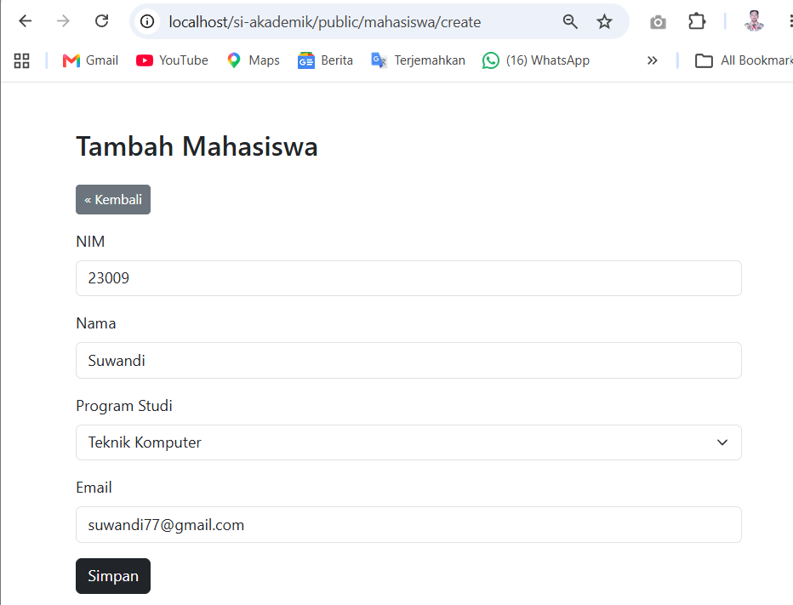

Klik Simpan
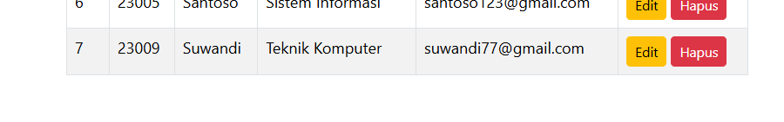
Data berhasil disimpan

Hapus data Mahasiswa
Klik hapus pada data yang dipilih

Muncul notifikasi, klik Ok
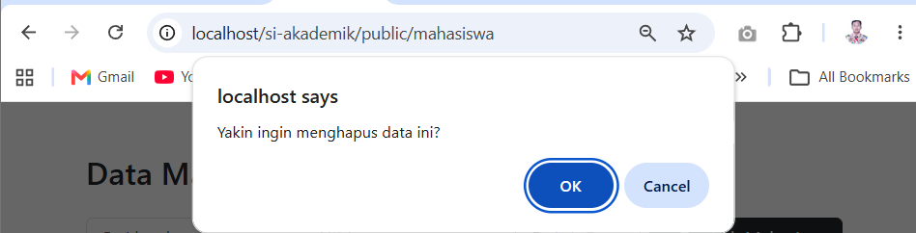

Data berhasil terhapus
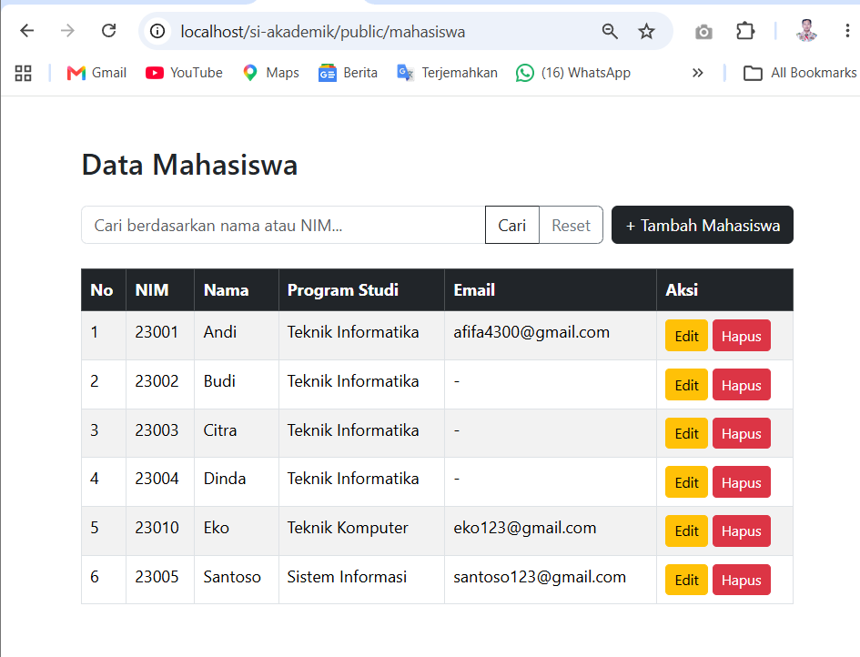

Update data
Pilih data yang akan di update
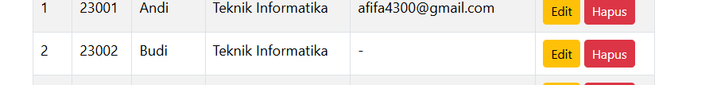

Klik edit, lalu masukkan data yang ingin diubah/diperbarui
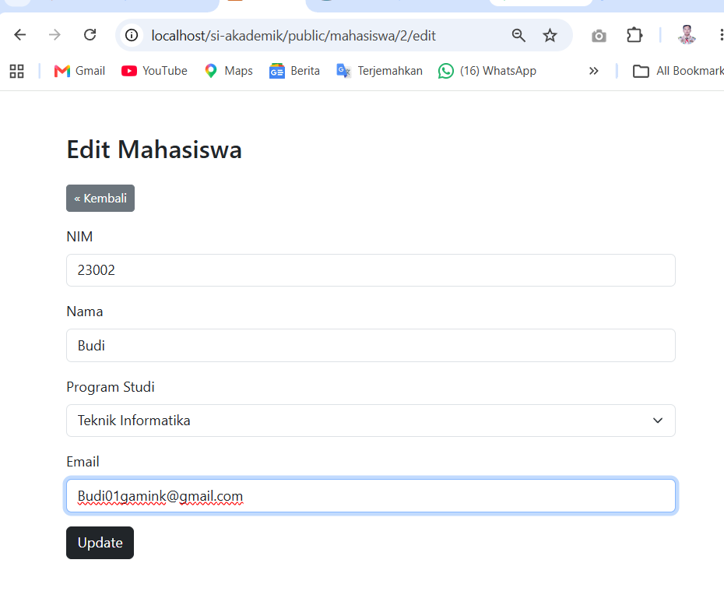

Klik Update
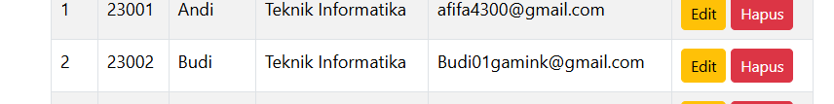
Data berhasil update

BAB 3 KESIMPULAN

